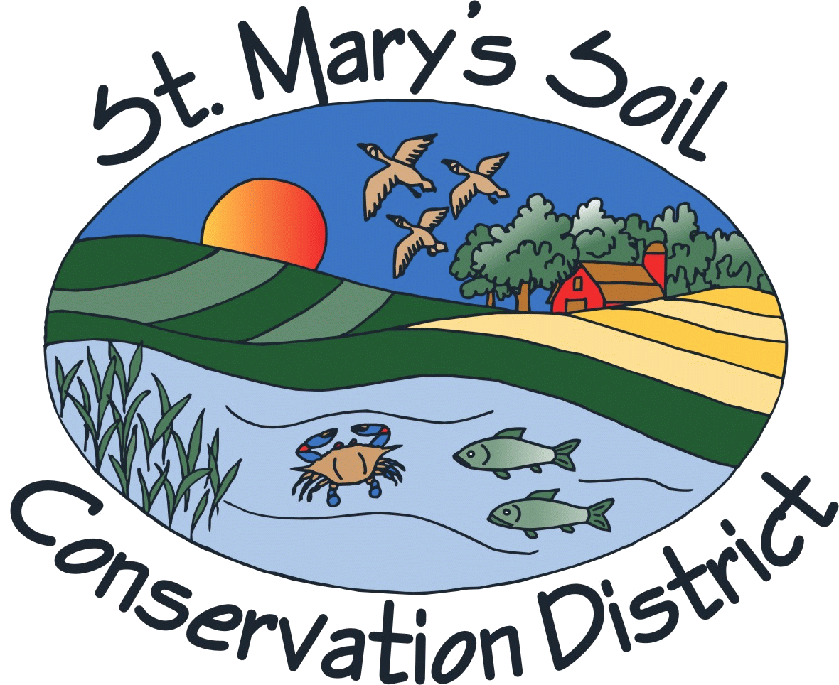 |  |  | ST. MARY’S SOIL CONSERVATION DISTRICT  APPLICATION FOR DISTRICT ASSOCIATE SUPERVISOR
Name |  |  |  |  |  |  | Phone
Home Address
Occupation
Place of Employment or Business
Business Address
The following information is requested to help the District select the best
qualified person to serve as an associate supervisor.
Please indicate areas of interest or expertise by checking any that may apply:

Agriculture |  | Sediment & Erosion Control | Public Information
NPS Pollution |  | Stormwater Management | Water Management
Chesapeake Bay |  | Environmental Education | Water Quality
Forestry |  | Wetlands | Wildlife
Other, please describe:

Please indicate any elected or appointed offices you now hold:
Are you familiar with the activities of soils conservation districts? If so, indicate which ones:
Are you currently, or have you in the past served, as an Associate Supervisor? |  |  | Yes No
If so, please indicate your involvement or participation in the following: (check all that apply)

Monthly SCD Meetings |  | Field Days/ Tours | MASCD Meetings
Special SCD Meetings |  | Local/State Workshops | NACD Regional Meetings
Technical Training Programs |  | Leadership Training | NACD National Meetings
Other, please identify:

Please explain briefly why you are interested in being a supervisor and would be a good choice for
this position:

I have read the list of “Facts Associate Supervisors Should Know” (see back). I am willing to have my name submitted for consideration as an associate supervisor and will serve if selected.
Signature of Applicant:____________________________________________________________ Date: ____________________
Return application to:
St. Mary’s Soil Conservation District
26737 Radio Station Way, Suite B
Leonardtown, MD 20650

FACTS ASSOCIATE SUPERVISORS SHOULD KNOW

- A Soil Conservation District is a political subdivision of the State. District boundaries are the same as county boundaries except that there are two (2) districts in Frederick County.

- The twenty-four (24) Soil Conservation Districts of Maryland have formed the Maryland Association of Soil Conservation Districts (MASCD) to effect cooperation between districts, coordinate the programs of the districts, and exchange information between the districts. The MASCD holds two (2) meetings each year. Supervisors keep abreast of issues and current activities by attending these meetings.

- Districts are encouraged to utilize associate supervisors as valuable additions to the Board. Associates are non-voting, volunteer members of the District Board of Supervisors.

- Associate Supervisors assist the District by contributing time, knowledge, and information helpful to developing and implementing the District’s soil conservation and water program.

- An associate supervisor is considered a training position for the post of District Supervisor.

- Associate supervisors are appointed by the District Board of Supervisors for one-year terms. Annual re-appointments are made after an evaluation of their contributions has been conducted.

- Associates Supervisors must attend a minimum of six (6) scheduled monthly board meetings in a twelve (12) month period and a minimum of one (1) special meeting (ex. Cooperators dinner meeting) to remain eligible for re-appointment.

- Associate supervisors are not eligible under state law to receive per diem or reimbursement of mileage from state funds.
11/7/11
revised 12/8/11

